

Online Registration Guide for contest
How to – Participate contest / self-check
EGISTER FOR CONTEST – The 3 STEP:

Note :
- Use reset password to retrieve existing account
- One email can be created with one user account only
- New users: Must fill exact & relevant details during registration. Existing users: Must update the profile data with relevant as per existing contest

Watch these videos to know the procedures

How to self-check
Login to account
Visit
cqc.wan-ifra.org
Join Quality contest
2
3
1
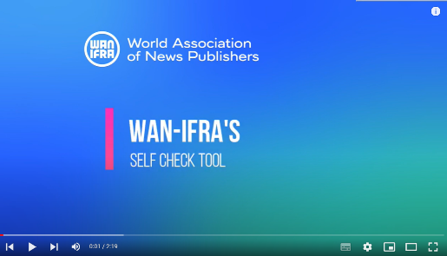

- Visit “https://cqc.wan-ifra.org/Login
- Login (Existing user : Reset password if need, new user: Register a new account)
- Join “Join Current Quality contest” - Dashboard >> Join current contest

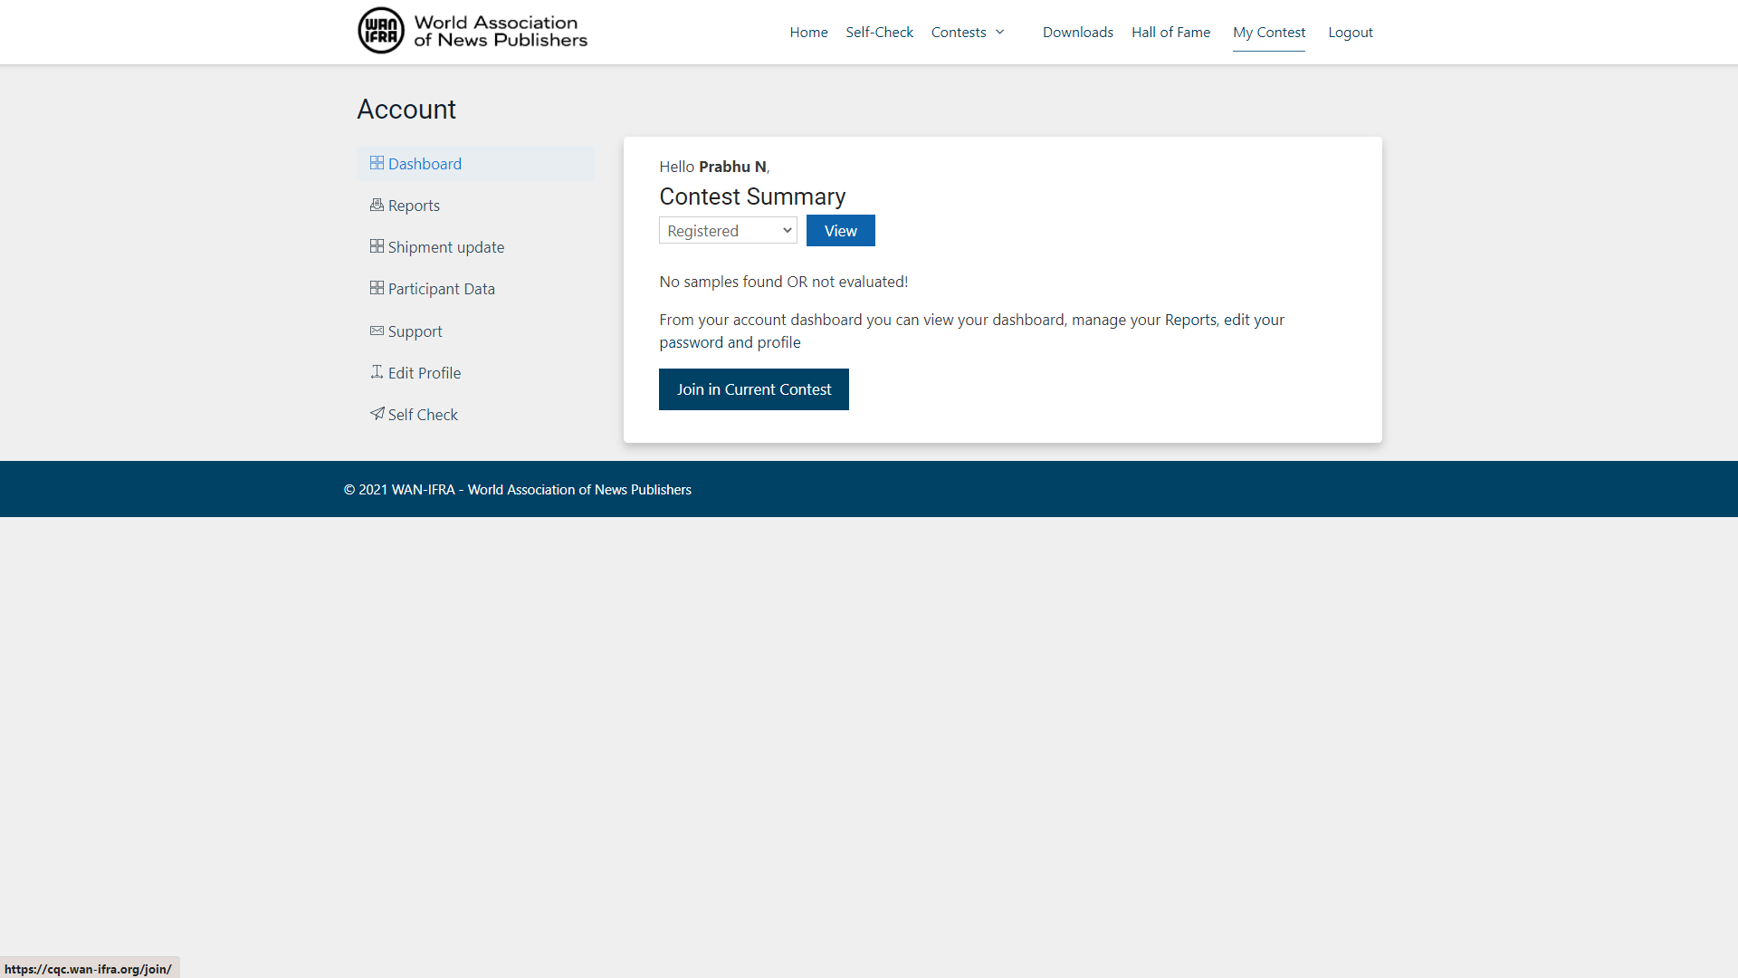
Dashboard
How to Register contest?

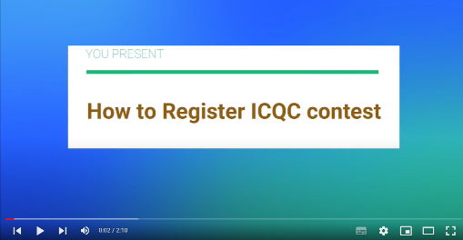

Contest registration & flow
2. WHAT NEXT? - AFTER REGISTRATION

- Receive registration confirmation email
- Await for invoice and pay the pay on-time (30days within, otherwise participation will be not confirmed)
- “DOWNLOAD” instructions & read through to familiarize targets procedures, and strictly adhere the timeline and terms.
- Receive reference cuboid to check and validate inter instrument checks
- Download cuboid as per your category (two cuboids available for CAT1 and CAT 2, 3, 4 & 5)
- Implement and test your process controls, variables and capabilities and finetune and optimize
- Adhere timelines:
  - Pre-check test run
  - The print schedule as
  - Shipping and last dates
- Follow the email communication on key updates/ procedures of the contest, like the key steps below during contest.
  - Registration confirmation
  - Reference cuboid & Cuboid availability
  - Invoice & payments request
  - Pre-checks timeline
  - Print schedule & Shipping timeline
  - Reports & membership status
  - Post contest procedures (winner book, event, etc.)

